**Supplementary Information:**

Reduced False Positives in Autism Screening Via Digital Bio-markers Inferred from Deep Co-morbidity Patterns

Dmytro Onishchenkoa, Yi Huanga, James van Hornea, Peter J. Smithd,g, Michael M. Msalle,f, Ishanu Chattopadhyaya,b,c,[1]

*aDepartment of Medicine, University of Chicago, Chicago, IL, USA*

*bCommittee on Genetics, Genomics & Systems Biology, University of Chicago, Chicago, IL, USA*

*cCommittee on Quantitative Methods in Social, Behavioral, and Health Sciences, University of Chicago, Chicago, IL, USA*

*dDepartment of Pediatrics, Section of Developmental and Behavioral Pediatrics, University of Chicago, Chicago, IL, USA*

*eDepartment of Pediatrics, Section Chief of Developmental and Behavioral Pediatrics, University of Chicago, Chicago, IL, USA*

*fJoseph P. Kennedy Research Center on Intellectual and Neurodevelopmental Disabilities, University of Chicago, Chicago, IL, USA*

*gExecutive Committee Chair, American Academy of Pediatrics’ Section on Developmental and Behavioral Pediatrics*

Table of Contents

​ 1. Detailed Mathematical Approach 9

​ 1.1. Time-series Modeling of Diagnostic History 9

​ 1.2. Step 1: Partitioning The Human Disease Spectrum 9

​ 1.3. Step 2: Model Inference & The Sequence Likelihood Defect 11

​ 1.4 Step 3: Risk Estimation Pipeline With Semi-supervised & Supervised Learning Modules 13

​ 2. Comparison With State of the Art Off-the-shelf ML Algorithms 13

​ 3. Comparison With Pipeline Variations, Feature Subsets and Neural Net Post-processing 14

​ 3.1. Feature Subset Evaluations & Code Density As A Feature 18

​ 4. Threshold Selection on ROC Curve 22

​ 5. Note on Reciever Operating Characteristics (ROC) and Precision-recall Curves 23

​ 6. Effect of Class Imbalance 24

​ 7. Note on ASD Clinical Diagnosis & Uncertainty of EHR Record 25

​ 7.1. Diagnostic Evaluations 26

​ 7.2. Change In Diagnostic Criteria for ASD, Inclusion of PDD, Asperger, and Disambiguation From Unrelated Psychiatric Phenotypes 27

​ 7.3. Performance Comparison With M-CHAT/F 28

​ 8. Improving Wait-times For Diagnostic Evaluations by Reducing False Positives in Routine Screening 28

​ 8.1. 4D Decision Optimization Using M-CHAT/F Population Stratification To Boost PPV 29

​ 9. Generating PFSA Models From Set of Input Streams with Variable Input Lengths 33

​ 10. Probabilsitic Finite State Automata Inference 33

​ 10.1. Probabilistic Finite-State Automaton 33

​ 11. Sequence Likelihood Defect 38

​ 12. Pipeline Optimization 41

​ 12.1. *Input Data Format* 41

​ 13. Example Run with Released Application 42

​ 13.1. Prerequisites & Installation 42

​ 13.2. EHR data format 42

​ 13.3. Sample Python code risk estimation 43

​ 13.4. Sample Python script risk estimation 44

**List of Tables**

1. Disease Categories With Detailed Set of ICD9 Codes Used………………………………………………..3
2. Boosted Sensitivity, Specificity and PPV Achieved at150 weeks Conditioned on M-CHAT/F Scores…31
3. Population Stratification Results on large M-CHAT/F Study(n=20,375)1…………………………………31
4. Computed from Population Stratification Recorded In M-CHAT/F Study1 ( = 0.0223)………….…..…31

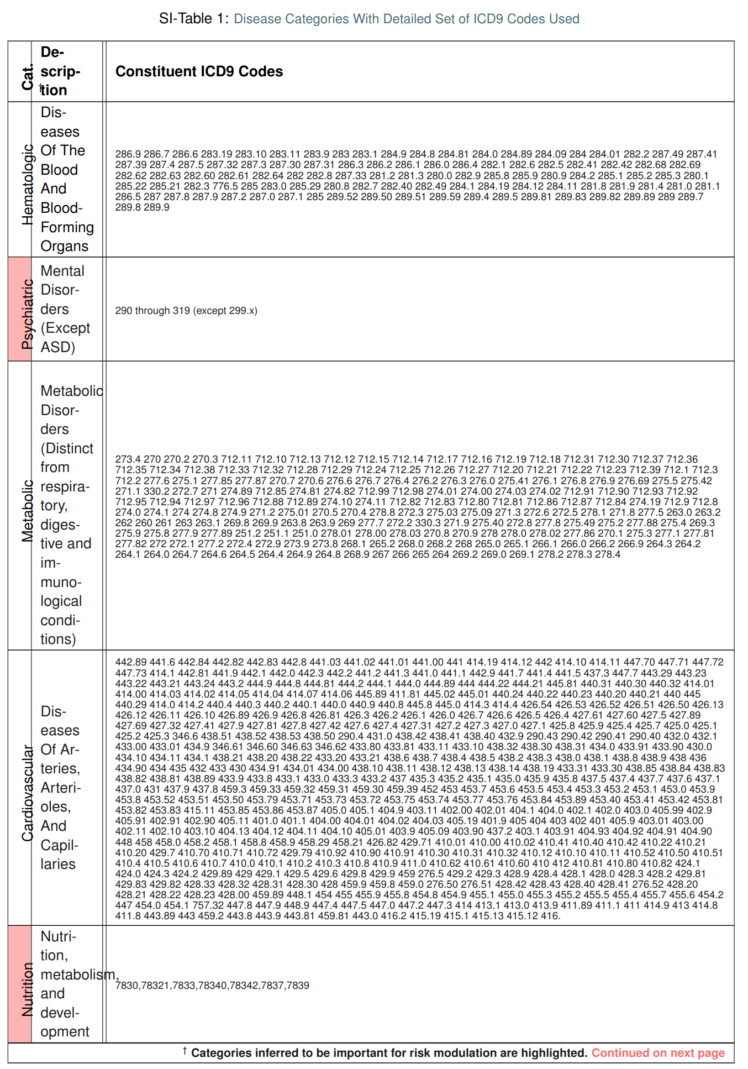

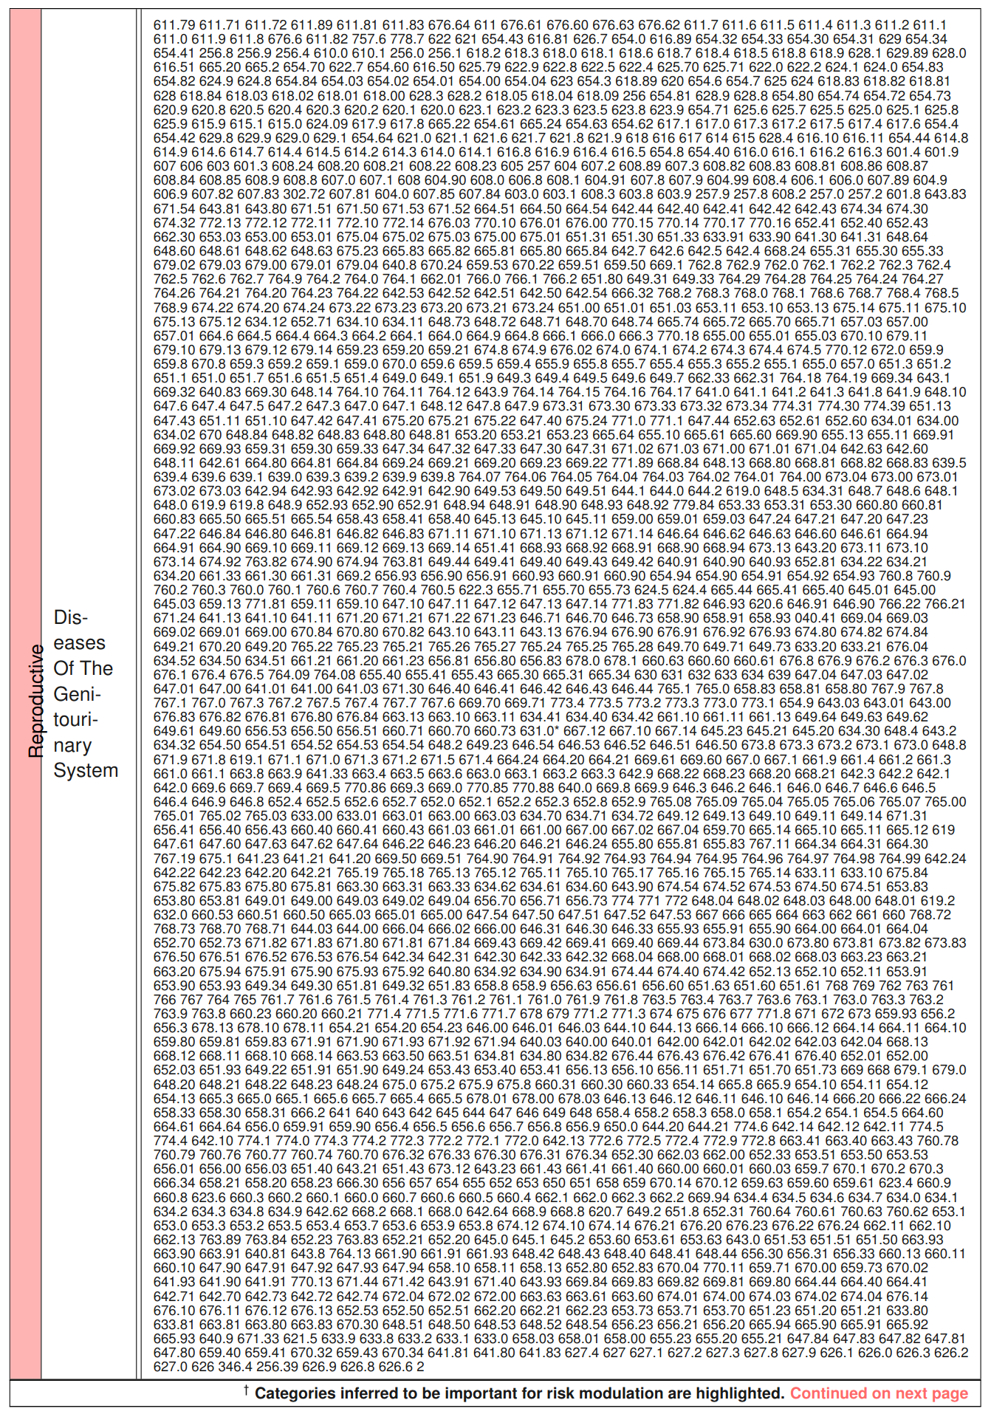

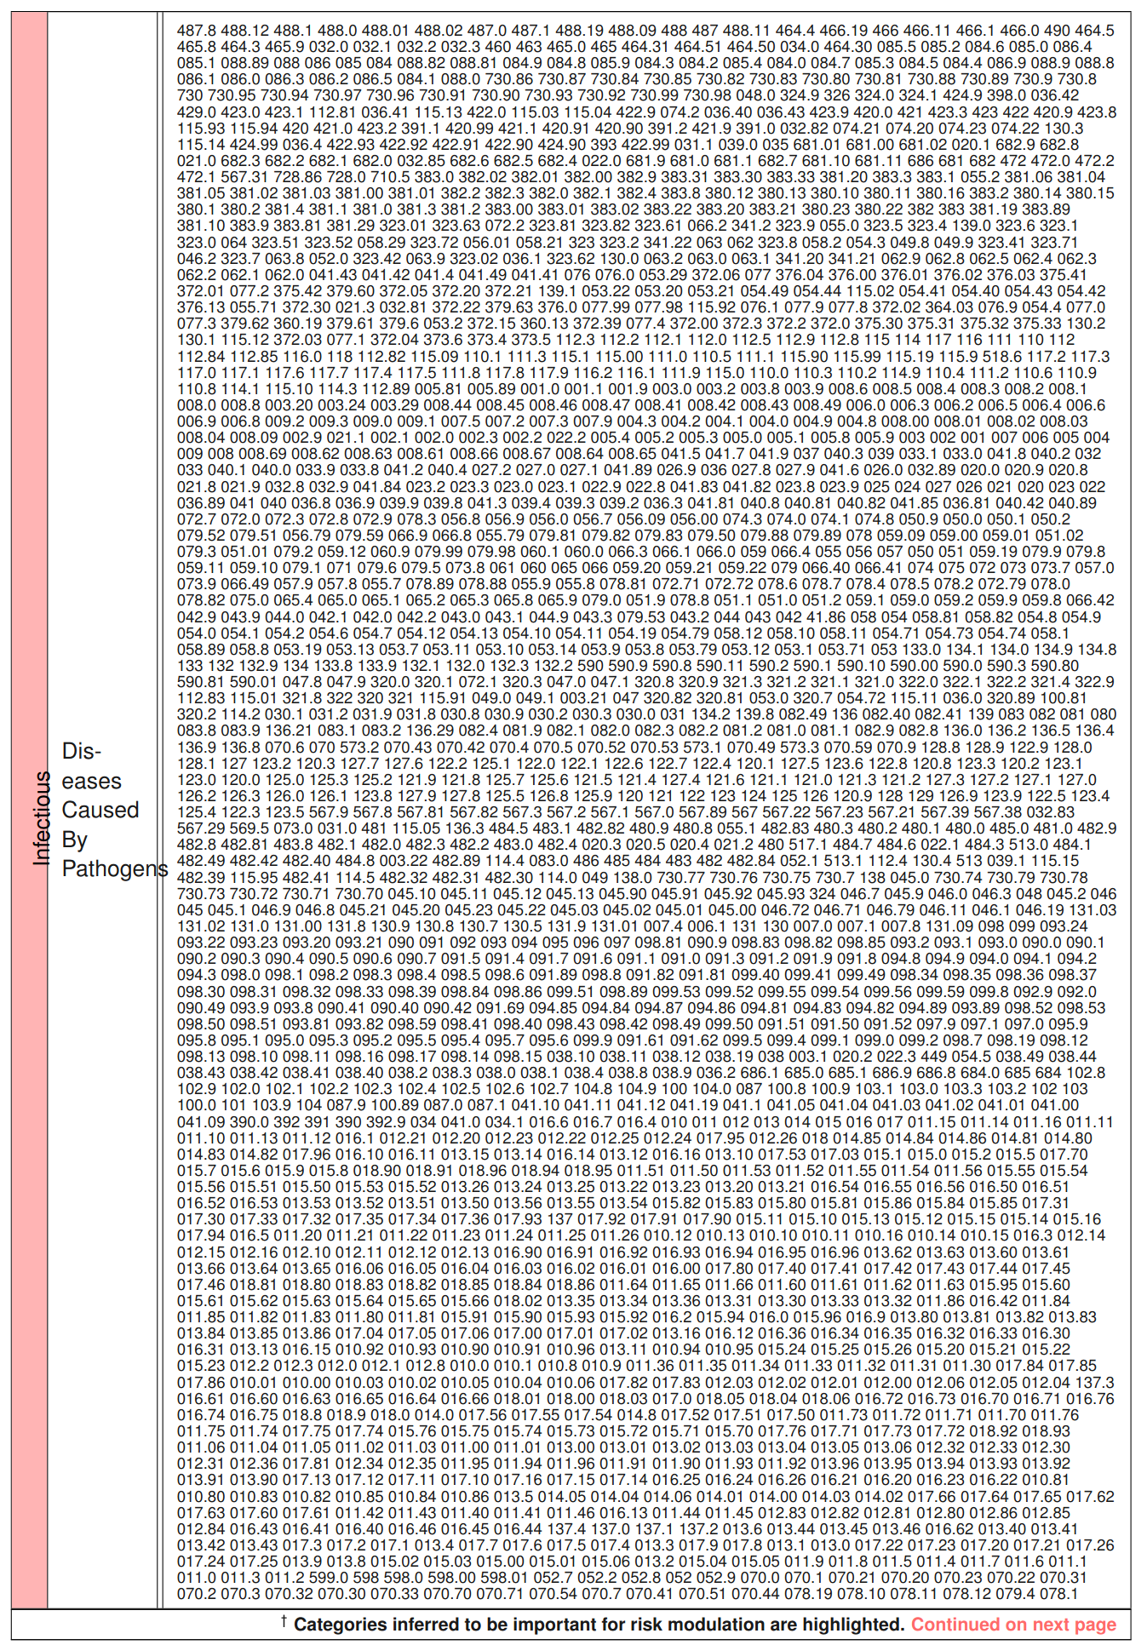

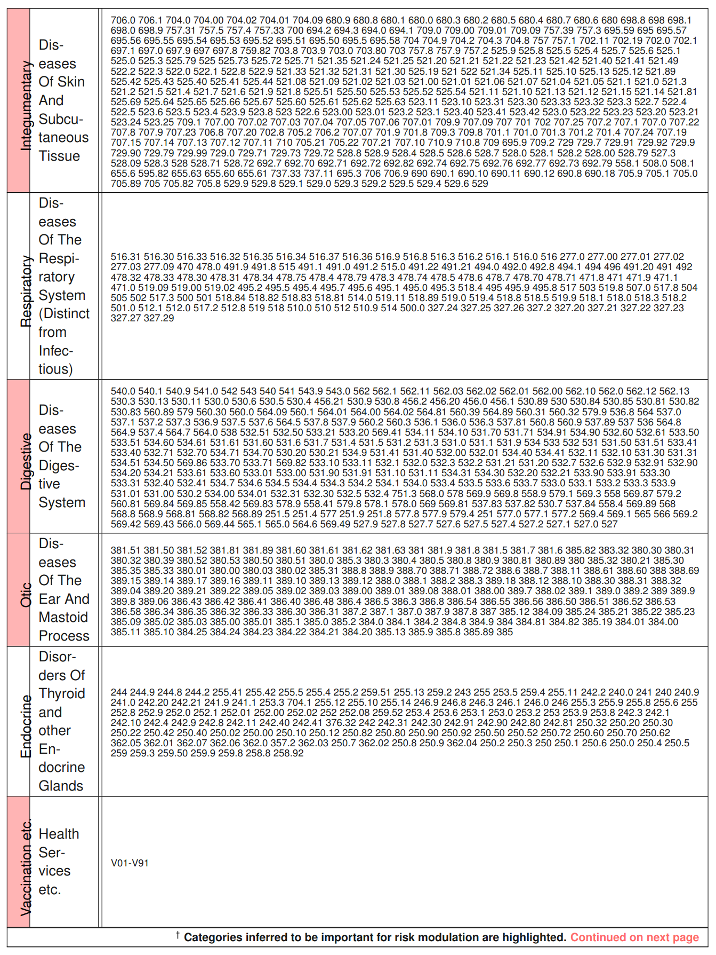

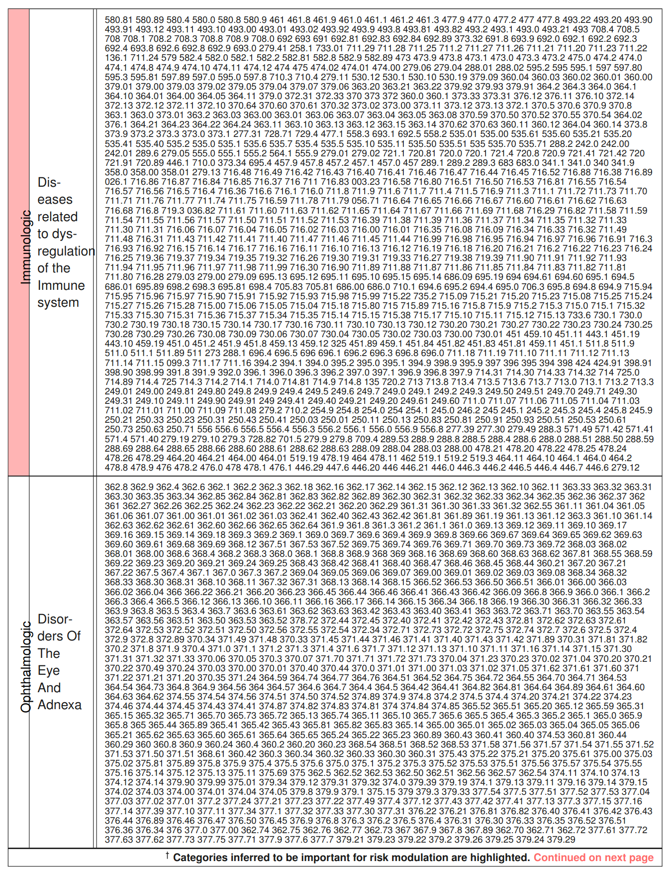

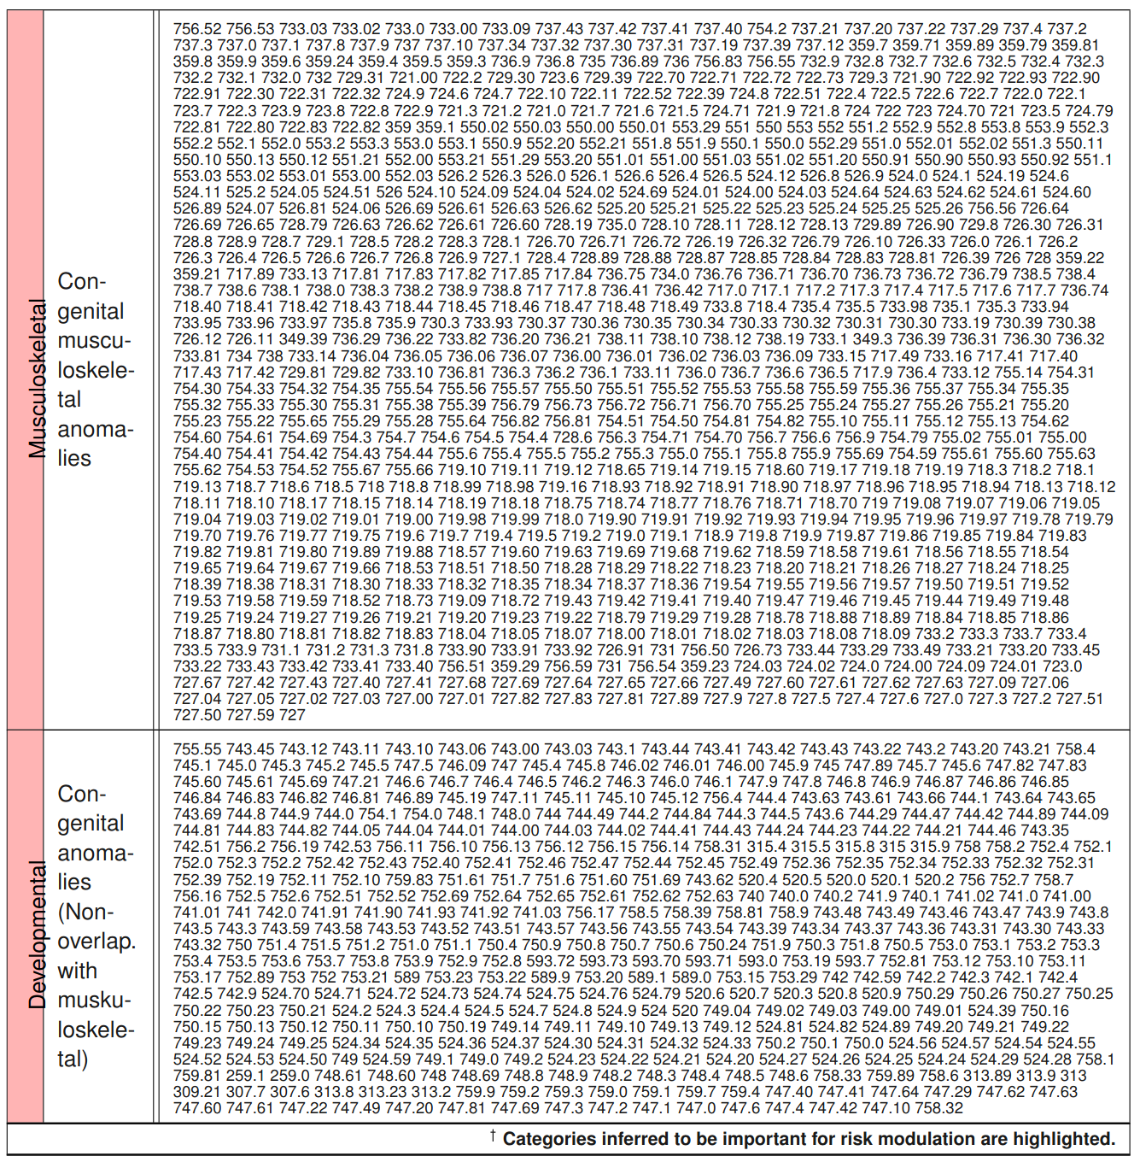

## 1. Detailed Mathematical Approach

### 1.1. Time-series Modeling of Diagnostic History

Individual diagnostic histories can have long-term memory2, implying that the order, frequency, and comorbid interactions between diseases are important for assessing the future risk of our target phenotype. We analyze patient-specific diagnostic code sequences by first representing the medical history of each patient as a set of stochastic categorical time-series | one each for a specific group of related disorders | followed by the inference of stochastic models for these individual data streams. These inferred generators are from a special class of Hidden Markov Models (HMMs), referred to as Probabilistic Finite State Automata (PFSA). The inference algorithm we use is distinct from classical HMM learning, and has important advantages related to its ability to infer structure, and its sample complexity (See Supplementary text, Section 10). We infer a separate class of models for the positive and control cohorts, and then the problem reduces to determining the probability that the short diagnostic history from a new patient arises from the positive as opposed to the control category of the inferred models.

### 1.2. Step 1: Partitioning The Human Disease Spectrum

We begin by partitioning the human disease spectrum into 17 non-overlapping categories. Each category is defined by a set of 9835 diagnostic codes from the International Classification of Diseases, Ninth Revision (ICD9) (See Table SI-1 in the Supplementary text for description of the categories used in this study). For this study, we considered 9835 distinct ICD9 codes (and their ICD10 General Equivalence Mappings (GEMS)4 equivalents). We came across 6,089 distinct ICD-9 codes and 11,522 distinct ICD-10 codes in total in the two datasets we analyzed. Transforming the diagnostic histories to report only the broad categories reduces the number of distinct codes that the pipeline needs to handle, thus improving statistical power. Our categories largely align with the top-level ICD9 categories, with small adjustments, e.g. bringing all infections under one category irrespective of the pathogen or the target organ. We do not pre-select the phenotypes; we want our algorithm to seek out the important patterns without any manual curation of the input data. The limitation of the set of phenotypes to 9835 unique codes arises from excluding patients from the database who have very few and rare codes that will skew the statistical estimates. As shown in Table 1a in the main text, we exclude a very small number of patients, and who have very short diagnostic histories with a very small number of codes.

For each patient, the past medical history is a sequence , where are timestamps and are ICD9 codes diagnosed at time . We map individual patient history to a three-alphabet categorical time series corresponding to the disease category , as follows. For each week , we have:



The time-series is terminated at a particular week if the patient is diagnosed with ASD the week after. Thus for patients in the control cohort, the length of the mapped trinary series is limited by the time for which the individual is observed within the 2003 - 2012 span of our database. In contrast, for patients in the positive cohort, the length of the mapped series reflect the time to the first ASD diagnosis. Patients do not necessarily enter the database at birth, and we prefix each series with 0s to approximately synchronize observations to age in weeks. Each patient is now represented by 17 mapped trinary series.



### 1.3. Step 2: Model Inference & The Sequence Likelihood Defect

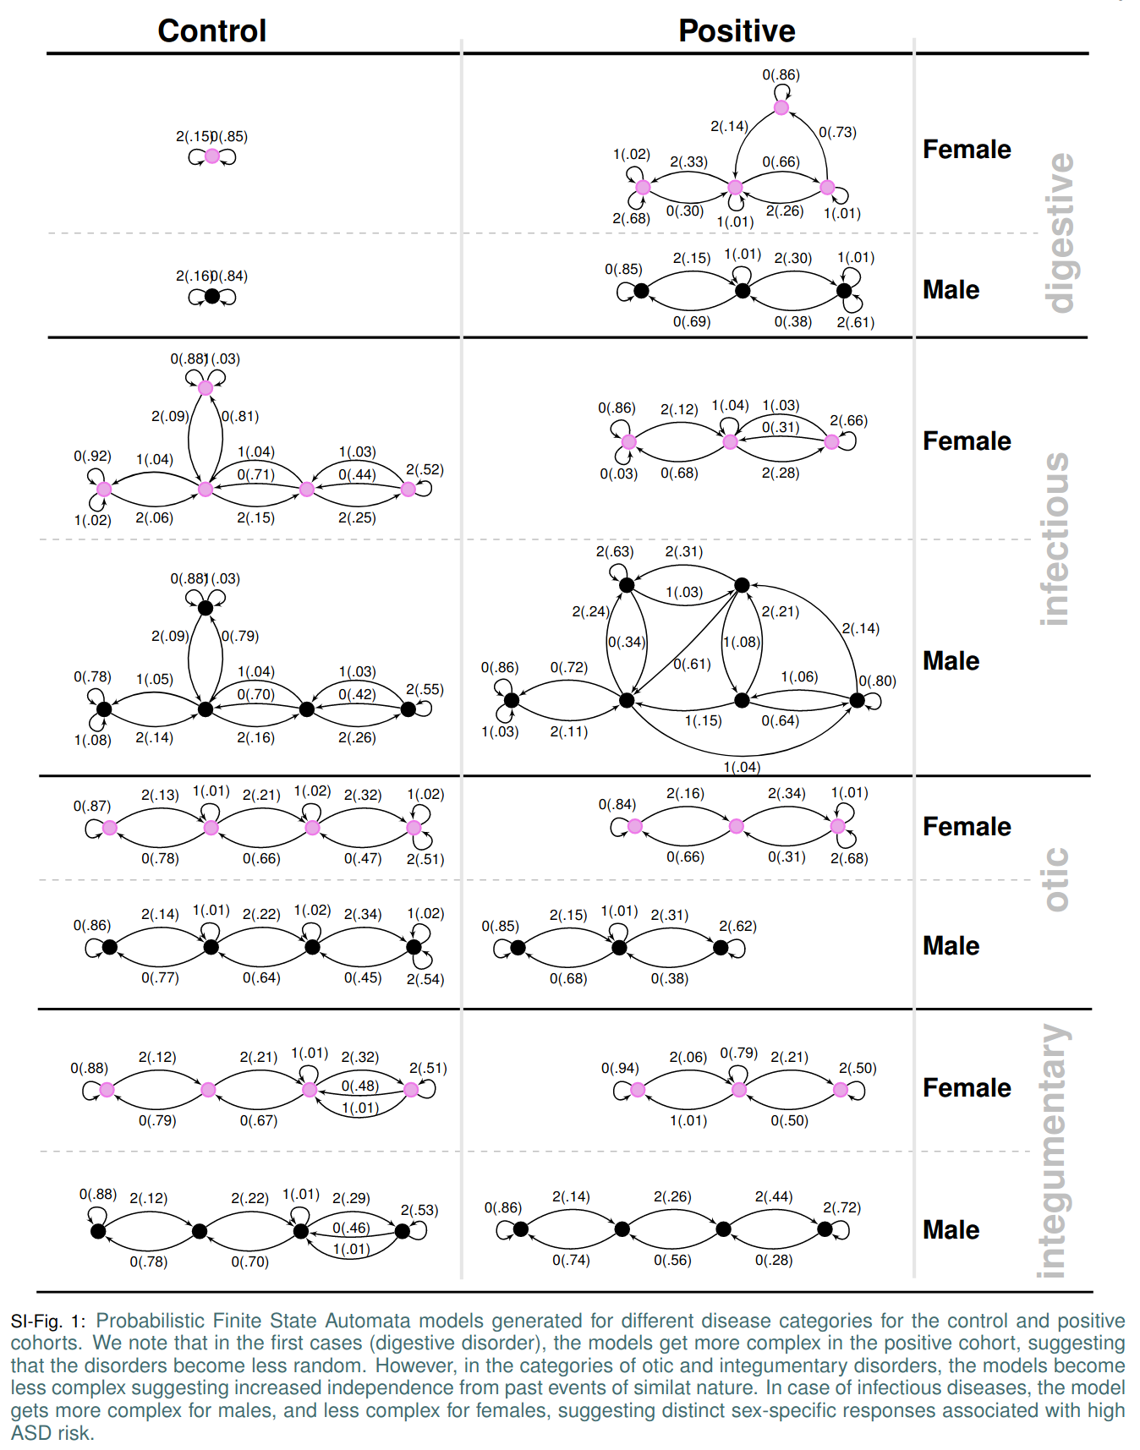

* + 1. The mapped series, stratified by sex, disease-category, and ASD diagnosis-status are considered to be independent sample paths, and we want to explicitly model these systems as specialized HMMs (PFSAs). We model the positive and the control cohorts for each sex, and in each disease category separately, ending up with a total of 68 HMMs at the population level (17 categories, 2 sexes, 2 cohort-types: positive and control, SI-Fig. 1 in the supplementary text provides some examples). Each of these inferred models is a PFSA; a directed graph with probability-weighted edges, and acts as an optimal generator of the stochastic process driving the sequential appearance of the three letters (as defined by Eq. (1)) corresponding to each sex, disease category, and cohort-type (See Section 10 in the Supplementary text for background on PFSA inference). To reliably infer the cohort-type of a new patient, i.e., the likelihood of a diagnostic sequence being generated by the corresponding cohort model, we generalize the notion of Kullbeck-Leibler (KL) divergence5,6 between probability distributions to a divergence between ergodic stationary categorical stochastic processes7 as:



where is the sequence length, and are the probabilities of sequence being generated by the processes respectively. Defining the log-likelihood of being generated by a process as :



The cohort-type for an observed sequence $x$— which is actually generated by the hidden process $G$— can be formally inferred from observations based on the following provable relationships (See Suppl. text Section 10, Theorem 6 and 7):

where is the entropy rate of a process5. Importantly, Eq. (4) shows that the computed likelihood has an additional non-negative contribution from the divergence term when we choose the incorrect generative process. Thus, if a patient is eventually going to be diagnosed with ASD, then we expect that the disease-specific mapped series corresponding to her diagnostic history be modeled by the PFSA in the positive cohort. Denoting the PFSA corresponding to disease category for positive and control cohorts as respectively, we can compute the *sequence likelihood defect* (SLD, ) as:





With the inferred PFSA models and the individual diagnostic history, we estimate the SLD measure on the right-hand side of Eqn. (5). The higher this likelihood defect, the higher the similarity of diagnosis history to that of children with autism.

### 1.4 Step 3: Risk Estimation Pipeline With Semi-supervised & Supervised Learning Modules

The risk estimation pipeline operates on patient specific information limited to the sex and available diagnostic history from birth, and produces an estimate of the relative risk of ASD diagnosis at a specific age, with an associated confidence value. To learn the parameters and associated model structures of this pipeline, we transform the patient specific data to a set of engineered features, and the feature vectors realized on the positive and control sets are used to train a gradient-boosting classifier8. The complete list of 165 features used is provided in Tab.1b in the main text.

We need two training sets: one to infer the models, and one to train the classifier with features derived from the inferred models. Thus, we do a random 3-way split of the set of unique patients into *feature-engineering* (25%), *training* (25%) and *test* (50%) sets. We use the feature-engineering set of ids first to infer our PFSA models (*unsupervised model inference in each category*), which then allows us to train the gradient-boosting classifier using the training set and PFSA models (*classical supervised learning*), and we finally execute out-of-sample validation on the test set. Fig.1B in the main text shows the top 15 features ranked in order of their relative importance (relative loss in performance when dropped out of the analysis).

## 2. Comparison With State of the Art Off-the-shelf ML Algorithms

Off the shelf algorithms with little or no pre-processing, i.e., using the diagnostic codes themselves are time-stamped categorical features failed to produce clinically relevant performance (See Fig. 2). Classifiers such as random forests9, and gradient boosters10 might be penalized due to their inability to take into account long-range temporal information. Since the number of diagnostic codes available per patient is small, recurrent neural network implementations such as LSTM11 might be suffering from the data sparsity in training. It is possible that the performance of the competing approaches might be improved with extensive tuning or clever feature-engineering.

## 3. Comparison With Pipeline Variations, Feature Subsets and Neural Net Post-processing

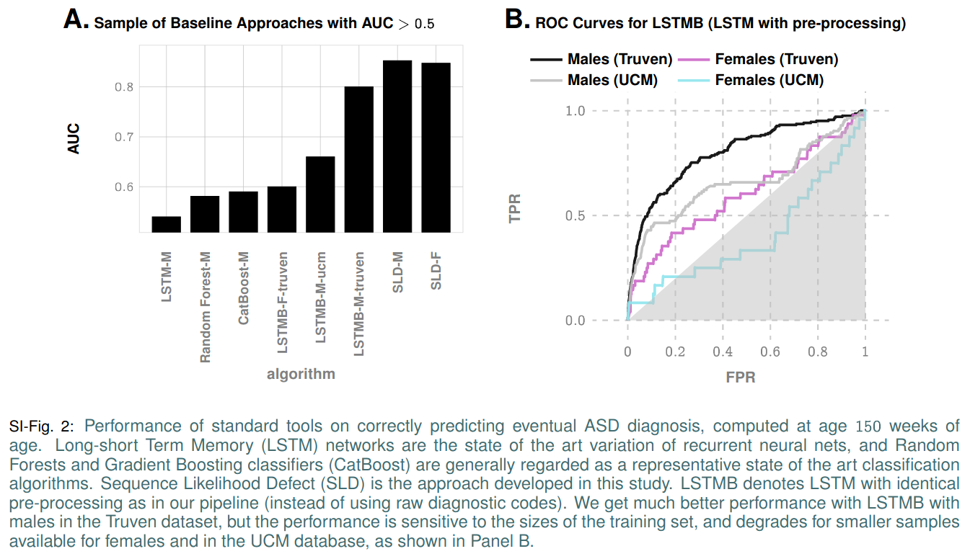In addition to the naive baseline approaches, we also evaluated the performance achievable with LSTMs (denoted as LSTMB in Fig. 2) that use identical preprocessing as our pipeline, i.e., representation of diagnostic histories as trinary sequences in 18 categories for each patient, and achieved ~80% AUC at 150 weeks for males in the Truven database (compared to >85% for our approach). However, the performances drop significantly when the number of positive samples is reduced, yielding an AUC of 66% on the UCM dataset for males, 60% for females on the Truven dataset, and a worse-than-random 40% on the UCM dataset respectively (See Fig. 2).

Much better results were obtained when we compared our optimized pipeline to pipelines that use only a subset of our features: namely, the ones that use only features derived from sequence statistics and exclude the ones derived from learning PFSAs (recall that PFSAs are special HMMs we learn using our novel algorithms) from the

disease categories as described in Methods in the main text, or using only the PFSA-based SLD features, or using simply the density of diagnostic codes (See Fig. 3, panel D). In all these cases we analyzed, our pipeline has a clearly demonstrable advantage (See Fig. 3, panel D) that is stable across databases, under reductions in sample sizes, and in balanced resampling experiments (See Fig. 3, panel C).

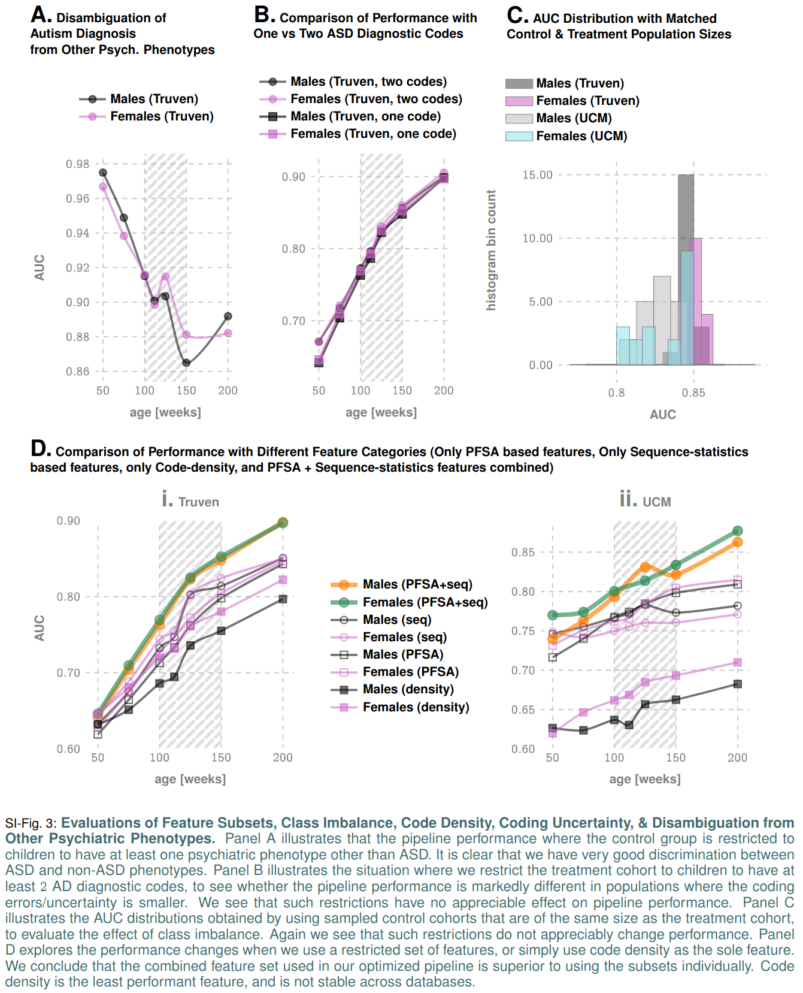

While it is difficult to explain the exact source of a modeling framework’s performance, and even more difficult to explain non-performance, we can point to the following advantages that our approach has over existing techniques:

1. **Purely Classification Algorithms With No Preprocessing Do not Do well.** Pure classifiers such as random forests, gradient boosters, etc. are not time series modeling frameworks, and might not capture stochastic temporal patterns well. While features are not certainly assumed to be independent in these algorithms, it is problematic to learn patterns that do not appear at fixed time points in the diagnostic history.
2. **Lower Sample Complexity Compared to Deep Learning Frameworks.** Compared to LSTMs and RNNs,we are able to capture stochastic behavior with more compact models, which results in better sample complexity. In other words, if we have less data, our models do better, because we estimate fewer parameters.
3. **Designed Bottom-up for Learning Stochastic Processes.** It is easily demonstrated that LSTMs and RNNs, while good models of complicated time series in many cases, do not work well for data that are generated by stochastic processes, i.e. are sample paths of a hidden process.
4. **We May Have Missed Some Clever Transformation.** It is possible that extensive tuning or feature selection with LSTMs, RNNs or CNNs or some combination thereof, can replicate our performance, or even do better. There will always be that possibility, notwithstanding how much effort we put in to evaluate competing techniques. *The authors welcome future work in this direction that surpasses our performance reported here; this is only going to help the patients which is what matters.*

### 3.1. Feature Subset Evaluations & Code Density As A Feature

With regards to Fig. 3, panel D, we note that the PFSA based features by themselves are comparable to those engineered manually from sequence statistics (the latter include features such as the proportion of codes in a patient’s history corresponding to specific disease categories, mean and variance of adjacent empty weeks 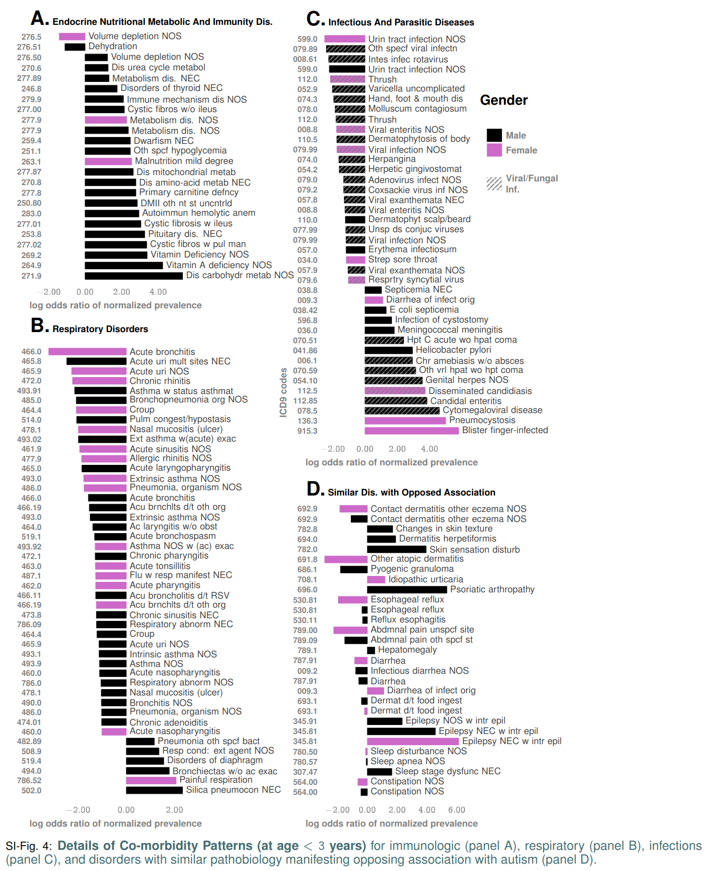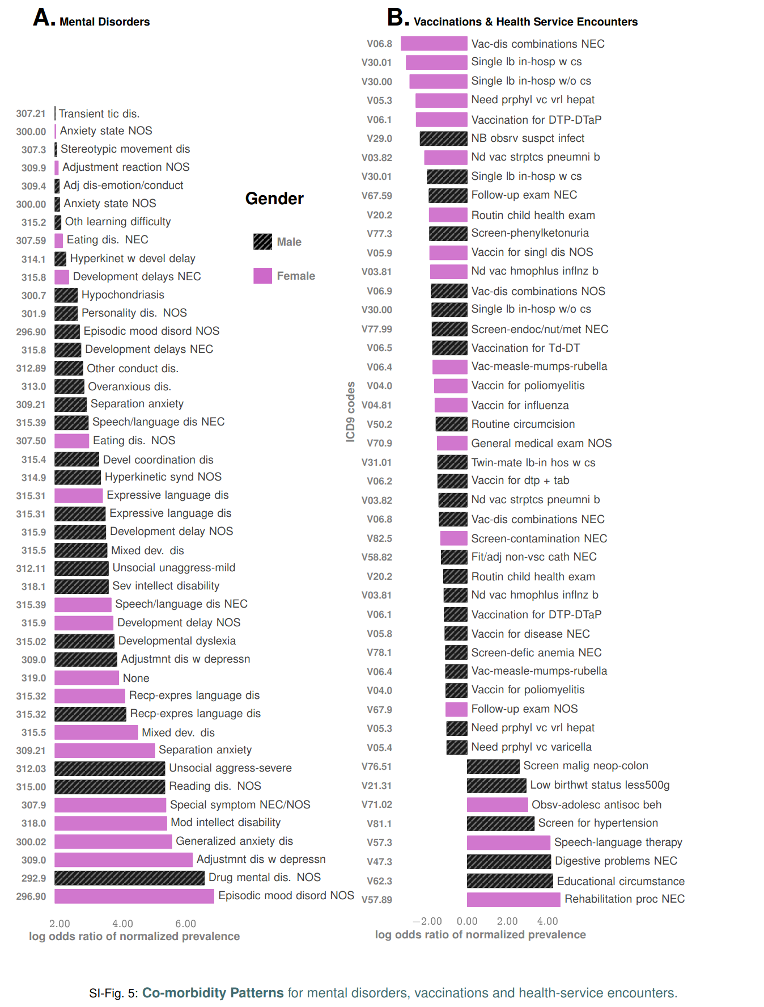, see main text Table 1b in the main text for details), but the combined runs produce significantly superior results. Also, it is interesting to note that simply using the density of diagnostic codes in a child’s history is quite predictive of future ASD diagnosis, with the AUC from using just the density of codes as a feature rising to over 75% in the Truven database at 150 weeks. However, it does not have stable predictive performance across databases, and is also the least performing predictor. We did not include code density in our combined feature set, since it has no effect once the rest of the features are combined.



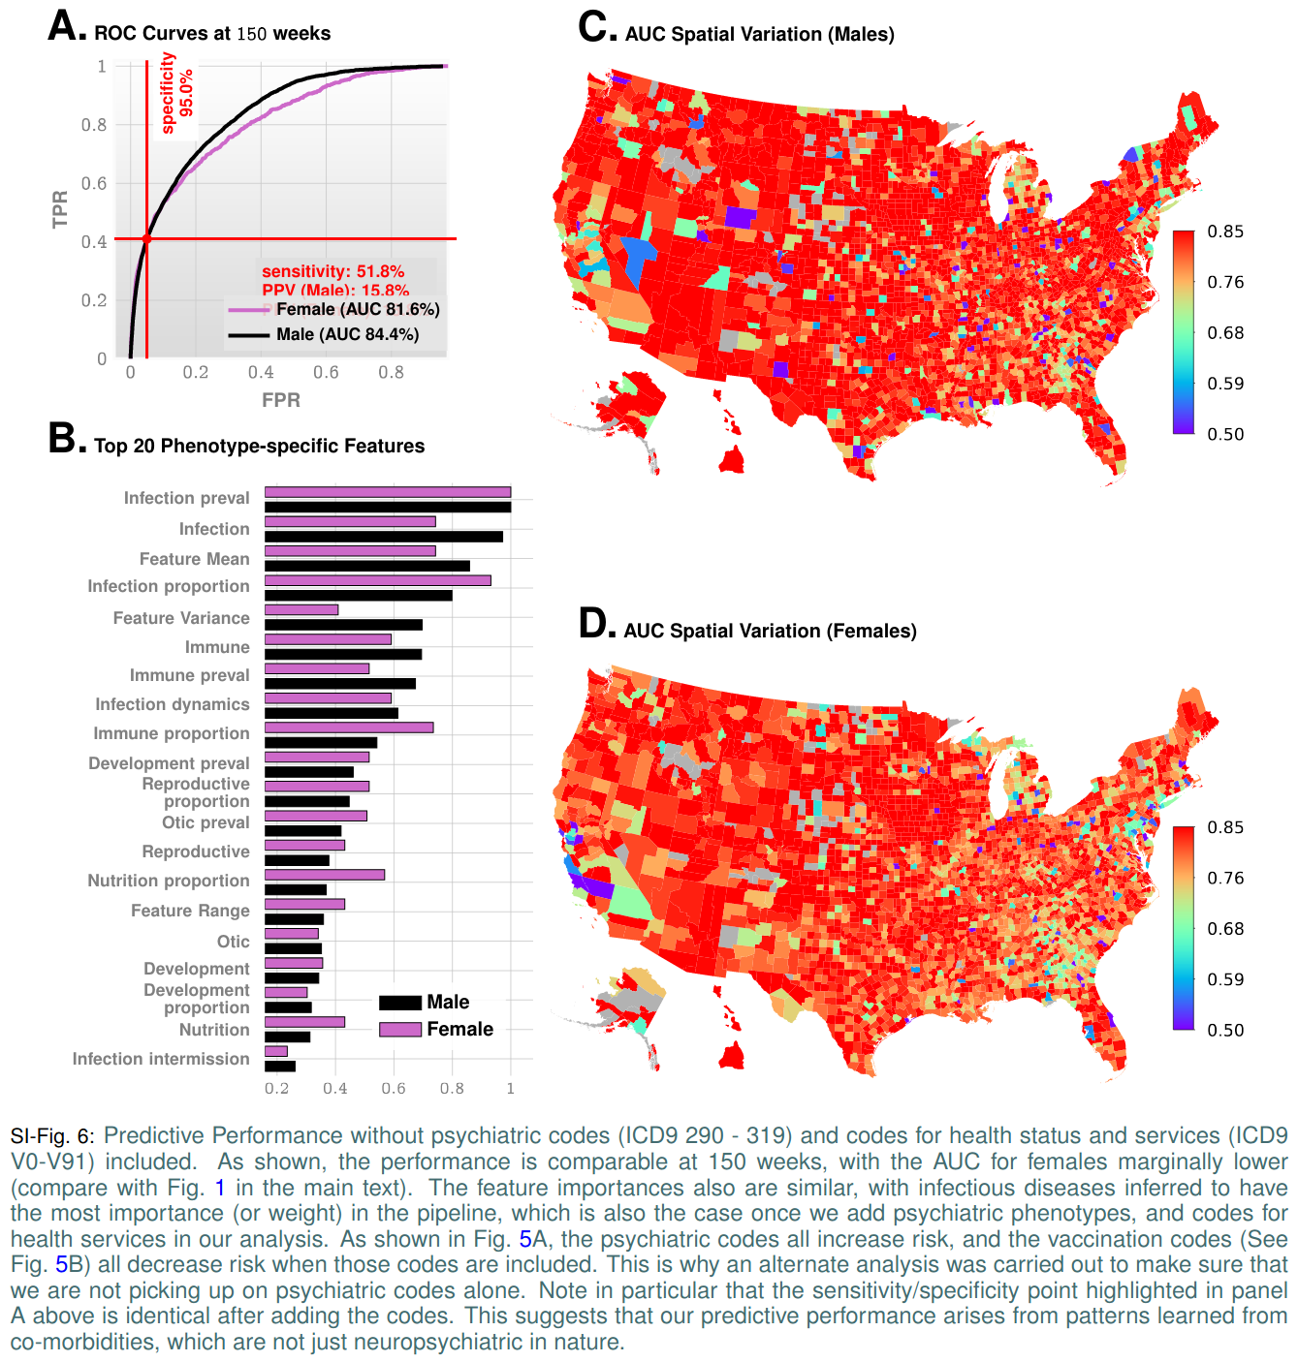

## 4. Threshold Selection on ROC Curve

Once the ROC curve has been computed, we must choose a decision threshold to trade-off true positive rate and false positive rate. In situations where the number of negatives vastly outnumber the number of positives (which is the case in our problem), it is better to base this trade-off on a measure that is independent of the number of true negatives. The two popular measures considered in the literature are accuracy and the F1-score:

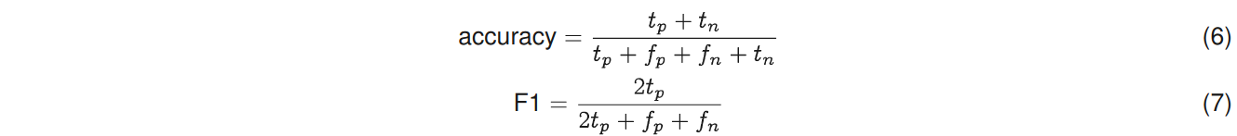

The F1-score is the same as accuracy where the number of true negatives is the same as the number of true positives, thus partially correcting for the class imbalance.

The selection of the threshold may also be dictated by the current practice of ensuring high specificities in screening tests. Thus, the most relevant clinically operating point is probably the one corresponding to 95% specificity, which is highlighted in Fig. 1C in the main text

## 5. Note on Reciever Operating Characteristics (ROC) and Precision-recall Curves

The ROC curve is a plot between the False Positive rate (TPR) and the True Positive Rate (TPR), and the area under the ROC curve (AUC) is often used as a measure of classifier performance. For the same of completeness, we introduce the relevant definitions:

In the following denotes the total number of positive samples (number of patients who are eventually diagnosed), and denotes the total number of negative samples (number of patients in the control group).

**Definition 1**. *True positive rate, true negative rate, false positive rate, positive predictive value (****PPV****), and* ***prevalence*** *() are defined as:*

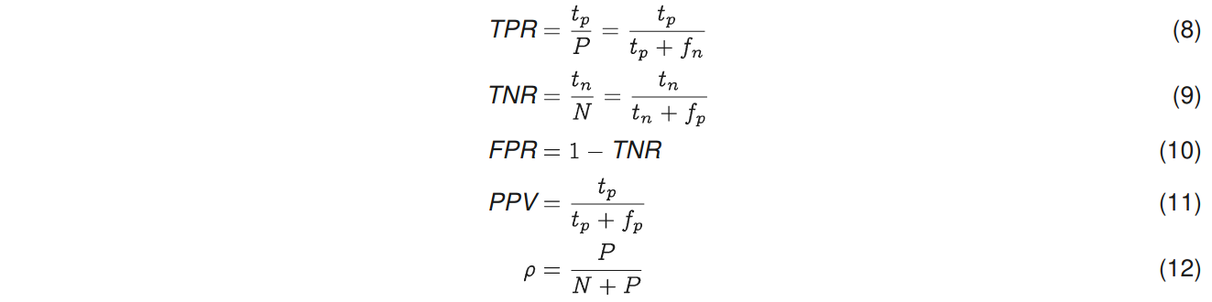

*where as before are true positives, true negatives, false positives, and false negatives respectively.*

Note that TPR is also referred to as **recall** or **sensitivity**, and PPV is also referred to as **precision**. True negative rate is also known as **specificity**.

A precision-recall curve, or a PPV-sensitivity curve is a plot between PPV and TPR.

Denoting sensitivity by , and specificity by , it follows that:

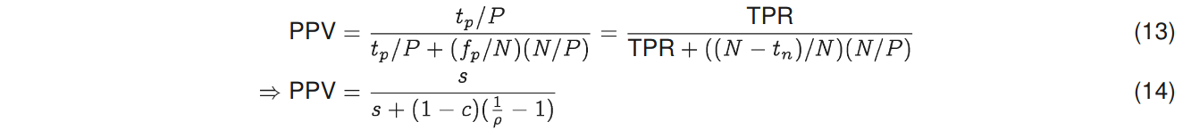Thus, we note that for a fixed specificity and sensitivity, the PPV depends on prevalence. Indeed, it is clear from the above argument that PPV decreases with decreasing prevalence, and vice versa, if specificity and sensitivity are held constant. Also, if prevalence is limited to 2%, and specificity is held at 95%, then the maximum PPV is limited to:

**This shows that for ASD screening, we can hope for a maximum PPV of ~29% at 95% specificity, if the prevalence is stable at around 2%.**

Compare this with the PPV of 15.8% (M) and 18.8% (F) that we achieve at 51.8% sensitivity, where the specificity is held at 95% in Fig. 1C in the main text. Note here that M-Chat/F with follow-up has a PPV of 14.6% as reported by the recent CHOP study1.

## 6. Effect of Class Imbalance

ROC curves are generally assumed to be robust to class imbalance. Note that if we assume that patient out-comes are independent (which is well-justified in the case of a non-communicable condition, particularly in large databases), then should scale linearly with the total number of positives , implying:



implying that with different sizes of the set of positive samples (or negative samples), the ROC curve remains unchanged. In particular, note that even if the prevalence is very small (say 0.01%), we cannot cheat to boost the AUC by labeling all predictions as negative, or stating that risk is always zero: in that case, our is very small, but our = 0 strictly, implying that our TPR = 0, thus leading to a zero AUC. We can cheat to boost the accuracy (See the previous section), but not the AUC.

Note that while relative class sizes or imbalance does not affect the ROC (under the assumption that true positives and true negatives scale with the number of positives and negatives), very small absolute sample sizes might still result in poor performance of the model.

We do have significant class imbalance in our datasets. This arises naturally from the low prevalence rate of ASD (small in the sense of comparison of sizes of the control and the positive cohorts). Thus, we validated if the performance of our predictive pipeline remains unchanged by replacing the full control cohort with a random sample of size equal to that of the positive cohort. The results, shown in Fig. 3C, illustrate that class imbalance has no appreciable effect on our pipeline, as far as the AUC metric is considered.

The precision-recall curves do get affected by class imbalance, or the prevalence, as shown by Eq (14). However, in diagnostic analysis, they are important since we are generally less interested in the number of true negatives; the ratio of false positives to the total number of positive recommendations by the algorithm is much more relevant, i.e., the PPV or the precision.

We have used this to our advantage. Note that since the PPV is affected by prevalence, a stratification of the total population with different prevalence in each sub-population suggests the possibility of a conditional choice of the operating point, thus boosting the overall PPV. We describe this approach in the sequel, in Section 8.1. First, we establish that our pipeline does not suffer from some important pitfalls arising in the workflows associated with ASD diagnosis, and how the diagnostic codes in Electronic Health Records (EHR) are generated.

## 7. Note on ASD Clinical Diagnosis & Uncertainty of EHR Record

With no precise laboratory test for ASD, most families experience the following sequence of events12–14: 1) routine screening at 18 and 24 months of age identifies high risk, and is followed by 2) a diagnostic evaluation. The American Academy of Pediatrics (AAP) recommends screening all children for symptoms of ASD at 18 and 24 months of age in their primary care visits15,16. However, results of a screening test are not diagnostic (*and hence do not produce an EHR diagnostic code*); they help the primary care provider identify children who are at risk for a diagnosis of ASD and require additional evaluation. The M-CHAT/F is the most studied and widely used tool for screening toddlers for ASD14,17.

Unfortunately, children with milder symptoms are harder to screen for. The AAP warns that children with milder symptoms and/or average or above-average intelligence may not be identified with symptoms until school age, when differences in social language or personal rigidities affect function14.

### 7.1. Diagnostic Evaluations

Once a child is determined to be at risk for a diagnosis of ASD, either by screening or surveillance, a timely referral is needed for clinical diagnostic evaluation13, which will, on positive identification, assign a clinical diagnosis, and produce an EHR record.

The history of symptoms of ASD presentation in individual patients may be elucidated by questionnaires such asthe Social Communication Questionnaire (SCQ), or Social Responsiveness Scale (SRS), or the Autism Diagnostic Interview-Revised (ADI-R)14. These questionnaires alone are insufficient for making a clinical diagnosis, but provide a structured approach to elicit symptoms. Validated observation tools used to provide structured data to confirm a clinical diagnosis include the Autism Diagnostic Observation Schedule, Second Edition (ADOS-2)18 and the Childhood Autism Rating Scale, Second Edition (CARS-2)19. Current guidance from the American Academy of Pediatrics14 notes that no single observation tool is universally appropriate, and that such tools are meant to support the application of the diagnostic criteria informed by history and other data.

At present, the Autism Diagnostic Interview-Revised (ADIR) and Autism Diagnostic Observation Schedule (ADOS) are considered the “gold standard” tools to enable the diagnosis of ASD20. The true “gold standard” classification and diagnosis of autism is historically taken to be a multi-disciplinary team (MDT) clinical assessment, including use of the ADOS and ADIR, as well as other assessments with consensus clinical judgment20. The MDT clinical diagnosis correct classification rate for ASD is approximately 80.8%. Thus, any individual tool that correctly classifies ASD at a rate of 80% or over could be considered to be just as accurate as the “gold standard”20. With ADOS-2 and associated tools verifiably reaching this classification rate, the current APA guidance suggests that individual general pediatricians might hand out initial diagnoses if they are familiar with the relevant DSM diagnostic criteria. This simultaneously raises the prevalence, and the possibility that some diagnostic codes pertaining to ASD in medical history databases could be arising from less restrictive workflows, and thus might carry more uncertainty. In our study, we checked if restricting the treatment cohort to children with at least two distinct ASD diagnostic codes in their medical histories instead of one (which significantly reduces the possibility of erroneous coding) changes the performance of the algorithm. The results shown in Fig. 3B illustrate that we have very little change in out-of-sample predictive performance, thus alleviating this concern.

### 7.2. Change In Diagnostic Criteria for ASD, Inclusion of PDD, Asperger, and Disambiguation From Unrelated Psychiatric Phenotypes

The DSM-5 established a single category of ASD to replace the subtypes of autistic disorder, Asperger syndrome, and pervasive developmental disorder not otherwise specified in the Diagnostic and Statistical Manual of Mental Disorders, Fourth Edition, Text Revision (DSM-IV-TR)14. This justifies our use of diagnostic codes from ICD9 299.X as specification of an ASD diagnosis, and use of GEMS mapping to 299.X for ICD10 codes when we encounter them. Future renditions of our pipeline will use purely ICD-10 specification, which does not change the algorithm, but merely how we input data into it.

It is interesting to note that we would be actually unable to discriminate between those phenotypes effectively for high predictability even if we wanted: in our initial efforts, we found it is very difficult to design a high performing pipeline that recognizes these sub-types separately.

The question then arises as to how well we can discriminate between ASD and other unrelated psychiatric phenotypes. Does our pipeline pick up on any psychiatric conditions, or is it specific to ASD? We directly evaluated this, by restricting the test control cohort to patients with at least one psychiatric code other than ASD. We get very high discrimination reaching AUCs over 90% at 100-125 weeks of age, which establishes that our pipeline is indeed largely specific to ASD.

### 7.3. Performance Comparison With M-CHAT/F

The M-CHAT/F is the most studied and widely used tool for screening toddlers for ASD14,17.

Guthrie et al.1 from the Children’s Hospital of Philadelphia (CHOP) demonstrate that when applied as a universal screening tool, M-CHAT/F has a sensitivity of 38.8%, specificity of 94.9% and PPV of 14.6%. This work is the only large-scale study of M-CHAT/F (n=20,375) we are aware of with sufficient follow-up after the age of four years to provide a reasonable degree of confidence in the sensitivity of M-CHAT/F.

Comparing the performance metrics achieved at different age groups across data sets and sexes for our pipeline (See main text Table 2a in the main text), we conclude that our approach produces a strictly superior PPV (exceeding M-CHAT/F PPV by at 14% (14.1-33.6%) when sensitivity and specificity are held at comparable values around the age of 26 months (112 weeks). We cannot compare at other operating points due to a lack of M-CHAT/F performance characterization anywhere else.

Apart from standalone performance, our proposed approach has several key advantages: it is clearly immune to parental educational level, and language barriers. Since access to insurance and medical records do get impacted by socio-economic variables, there is the possibility of some indirect impact from the demographic makeup of the training datasets. But overall, diagnostic histories are free from biases that have historically plagued questionnaire-based screens14. Additionally, while M-CHAT/F is relatively easy and quick to administer, the issue of time and resource commitment cannot be ignored14. These factors conspire to produce reduced coverage, which in turn casts doubt upon the necessity of universal screening programs despite clear guidance on the contrary from the AAP1.

Additionally, being functionally independent of the M-CHAT/F, we can take advantage of any population stratification induced by the M-CHAT/F results to significantly boost combined screening performance.

## 8. Improving Wait-times For Diagnostic Evaluations by Reducing False Positives in Routine Screening

While children with ASD can be diagnosed as toddlers21,22 (developmental concerns may show up before the firstbirthday23,24), the mean age of diagnosis is over 4 years25. Since a clinical diagnosis of ASD requires the multi-step process described in the previous section, this delay mainly arises from extended wait-times and queues, which ultimately delays entry into early intervention (EI) programs. While time-consuming evaluations26, cost of care27, lack of providers28, lack of comfort in diagnosing by primary care providers28, and other challenges, are all responsible to varying degrees that culminate in these delays12, one rather obvious source is the limited PPV of screening tests that are available today. With the PPV of M-CHAT/F being around 14.6%, over 85 out of 100 people flagged for diagnostic evaluation are false positives, leading to wait times that currently range from 3 months to 1 year. To make matters worse, access to care and resources are sparse except near urban centers. For example, only 7% of developmental pediatricians practice in rural areas, and some states do not even have a developmental pediatrician12,29. A key contribution of this work is to be able to significantly reduce the number of false positives without sacrificing specificity, and thus significantly improving wait-times and patient outcomes.

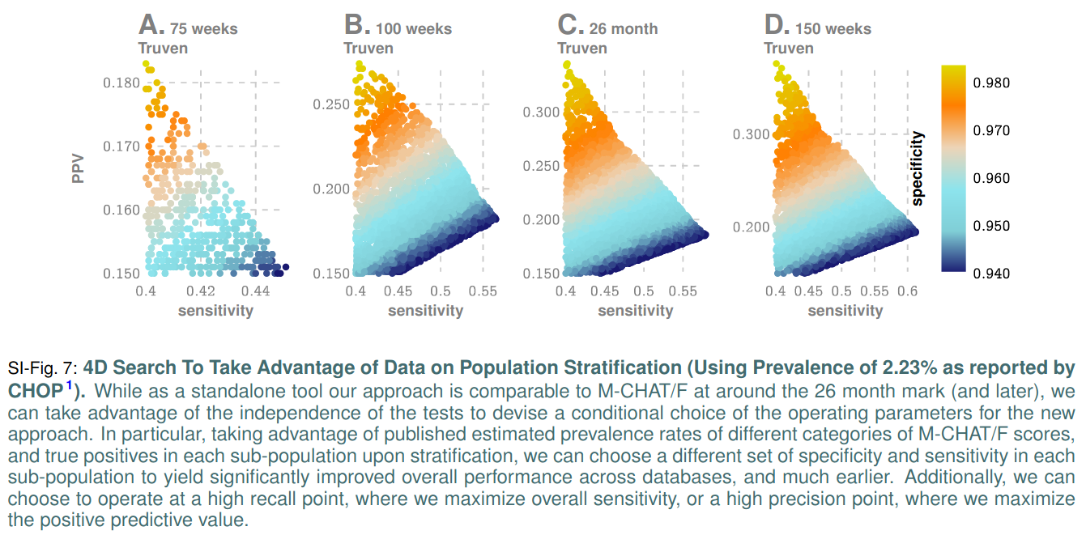

### 8.1. 4D Decision Optimization Using M-CHAT/F Population Stratification To Boost PPV

Assume that there are sub-populations such that: the total number of positives and negatives, and the prevalences in each sub-population are given by and respectively, with . Let be the relative size of the sub-populations. Thus, we have

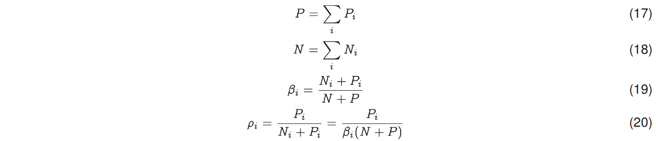

Therefore, denoting the sensitivity and specificity of the sub-populations as and respectively, we have:



Thus, we end up with:

where we have denoted:

Now, using Table 3, we can compute the values for , as shown below.

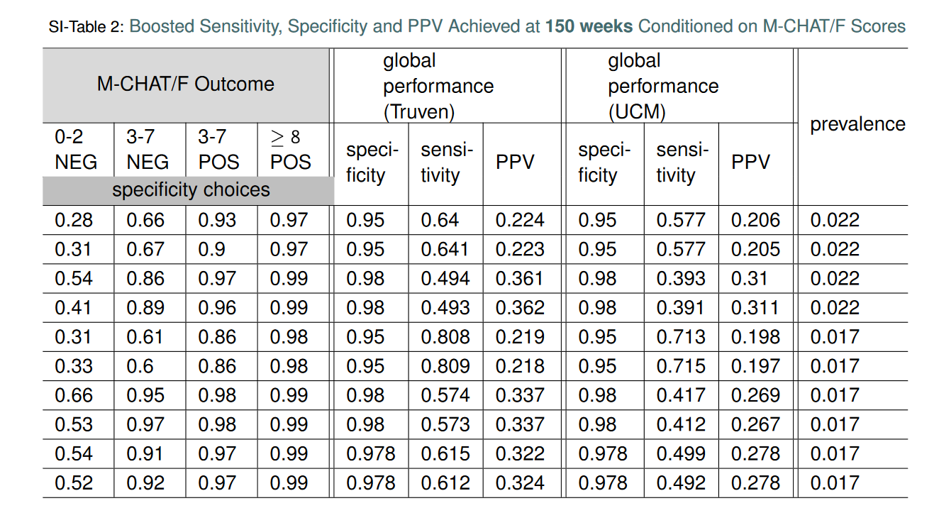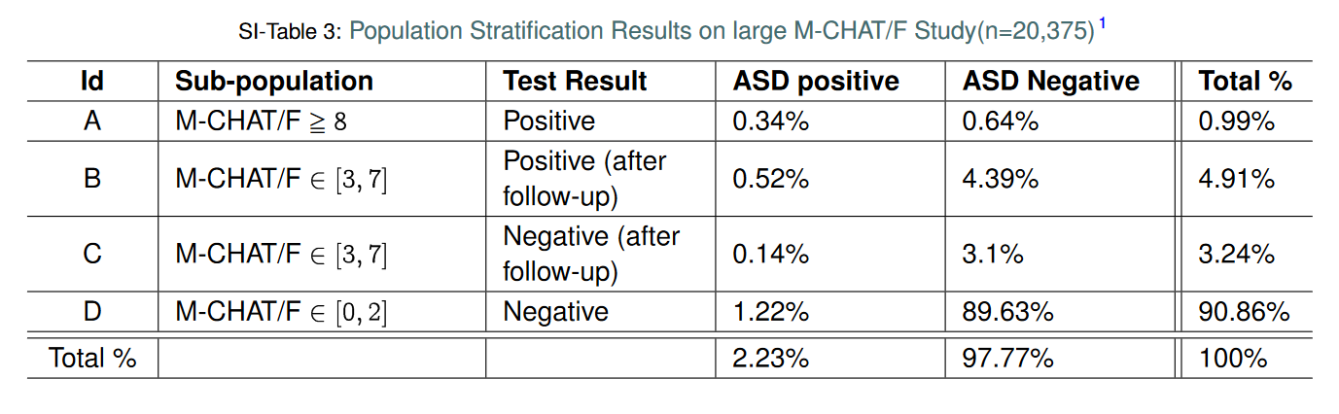

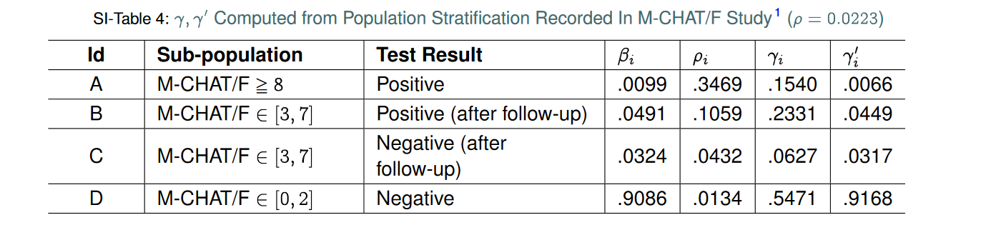Using the prevalence and stratification parameters calculated from the CHOP study (See main text Table 41), we can compute a conditional choice of sensitivity and specificity for our tool, in each sub-population to ultimately yield an overall performance significantly superior to M-CHAT/F. We carry out a four-dimensional search at the age the CHOP population stratification is reported (26 months or 112 weeks approximately) to identify the feasible region with PPV >14.6%, or sensitivity >38.8% while keeping specificity >94.9% where each of these dimensions represent the independent choice of sensitivity in the corresponding sub-population. For each set of 4 choices, the corresponding specificities are read-off from our computed ROC curve, and then the overall sensitivity, specificity and PPV are calculated using Eq. (22). The results are shown in Fig. 7, where we include the computations at 75 weeks, 125 weeks, and 150 weeks, with the same population stratification (although understandably the stratification will deviate from the values obtained at 26 months for those other ages).

An important assumption here is that the two tests are independent. Since M-CHAT/F is based on the detection of behavioral signals of developmental delay associated with autism via questionnaires completed by the primary care-givers, while our pipeline is based on physical comorbidities, independence is reasonable. Hence, we can simulate the application of the pipeline to each sub-population, and compute the overall performance quantities using a pre-computed ROC curve. Here we use the curve corresponding to the age in weeks, but average the male and female ROC curves, which are close as shown in Fig. 1 in the main text. The male-female averaging is necessary since the results from the CHOP study does not report sex stratified data.

We show the feasible region obtained by this computation in Fig. 7 of this document, and in main text Fig. 3 of the main text. Particularly, note that we get a PPV close to or higher than30%at the high precision (HP) operating point, or a sensitivity above 55% for the high recall (HR) operating point, when we restrict specificities to above 95%.

It is important to note that Eq. (22) and hence the results are dependent on the population prevalence . We report the dependence of the solution to the 4D optimization for population prevalence between 1.7% (CDC estimate14), and 2.23% (CHOP estimate1). In particular, it is illuminating to compare these results directly with M-CHAT/F performance, as shown in Fig. 3, panels B and C in the main text. In panel C, we show that for any stable population prevalence between 1.7% and 2.24%, we can achieve nearly double the PPV without losing sensitivity, or increase the sensitivity by about 50% without sacrificing PPV, while holding not letting the specificity to drop below 94%.

## 9. Generating PFSA Models From Set of Input Streams with Variable Input Lengths

Our PFSA reconstruction algorithm3 is distinct from standard HMM learning. We do not need to pre-specify structures, or the number of states in the algorithm, and all model parameters are inferred directly from data. Additionally, we can operate either with 1) a single input stream, or 2) a set of input streams of possibly varying lengths which are assumed to be different and independent sample paths from the unknown stochastic generator we are trying to infer. At an intuitive level, we use the input data to infer the length of histories one must remember to estimate the current state, and predict futures for the process being modeled. Thus, we do not step through the symbol streams with a pre-specified model structure, and avoid the need to have equal-length inputs. More details of the algorithm are provided in the next section.

The ability to model a set of input streams of varying lengths is particularly important, since medical histories of different patients are typically of different lengths.

## 10. Probabilsitic Finite State Automata Inference

### 10.1. Probabilistic Finite-State Automaton

Let # be a finite alphabet of symbols with size . The set of sequences of length over is denoted by The set of finite but unbounded sequences over is denoted by , the Kleene star operation30, i.e. . We use lower case Greek, for example or , for symbols in , and lower case Latin, for example or , for sequences of symbols, i.e. . We use to denote the length of . The empty sequence is denoted by .

We denote the set of strictly infinite sequences over by , and the set of strictly infinite sequences having as prefix by . Let S = , we can verify that is a semiring31 over . We use to denote the sigma algebra generated by .



**Definition 2** (Stochastic Process over ). *A stochastic process over a finite alphabet is a collection of -valued random variables indexed by positive integers32.*

We are specifically interested in processes in which the s are not necessarily independently distributed.

**Definition 3** (Sequence-Induced Measure and Derivative). *For a process , let or simply denote the probability producing a sample path prefixed by . The* ***measure induced by a sequence*** *Is the extension31 to of the premeasure defined on the semiring given by*



*For any , the* ***-th order derivative*** *of a sequence , written as , is defined to be the marginal distribution of on , with the entry indexed by denoted by . The first-order derivative is called the* ***symbolic derivative*** *and is denoted by for short.*



**Definition 4** (Probabilistic Nerode Equivalence and Causal States33).

*For any pair of sequences , is equivalent toy, written as , if and only if either , or . The equivalence class of a sequence is denoted by and is called a* ***causal state****34. The cardinality of the set of causal states is called the* ***probabilistic Nerode index****, or the Nerode index for simplicity.*

We can see from the definition that causal states captures how the history of a process influences its future. Since the probabilistic Nerode equivalence is right invariant, it gives rise naturally to a automaton structure introduced below.

**Definition 5** (Probabilistic Finite-State Automaton (PFSA)). *A PFSA is defined by a quadruple , where is a finite set, is a finite alphabet, is called the transition map, and , where is the space of probability distributions over , is called the transition probability. The entry of indexed by is denoted by .*

**Definition 6** (Transition and Observation Matrices). *The transition matrix is the matrix with the entry indexed by written as , satisfying*

*and the observation matrix is matrix with the entry indexed by equaling .*

*We note that both and are stochastic, non-negative with rows summing up to 1.*



**Definition 7** (Extension of and to ). *For any is defined recursively by*



*with and is defined recursively by*

*with .*

**Definition 8** (Strongly Connected PFSA). *We say a PFSA is strongly connected if the underlying directed graph is strongly connected35. More precisely, a PFSA is strongly connected if for any pair of distinct states and , there is an such that .*



We assume all PFSA in the discussions in the sequel are strongly connected if not specified otherwise. For strongly connected PFSA , there is a unique probability distribution over that satisfies . This is the stationary distribution36,37 of and is denoted as , or if is understood.

**Definition 9** (-Expression). *We can encode the information contained in and by a set of matrices , where*

 *is called* ***event-specific transition matrix****, with the event being that is current the output. can also be extended to arbitrary by defining , with .*

**Definition 10** (Sequence-Induced Distribution on States). *For a PFSA and a distribution on , the* ***distribution on induced by a sequence*** *is given by with . The entry indexed by of the vector is written as . When , the stationary distribution of , we write as , or simply as , if is understood.*

**Definition 11** (Stochastic Process Generated by a PFSA). *Let be a PFSA and let be a distribution on , the -valued stochastic process generated by and satisfies that follows the distribution and follows the distribution for .*

*For the rest of this paper, we will assume if not specified otherwise. We can show that, when initialized with , the process generated by a PFSA is stationary and ergodic. We also note the, for the process generate by , we have . Since , the symbolic derivative of the empty sequence is the stationary distribution on the symbols.*

**Definition 12** (Synchronizable PFSA and Synchronizing Sequence). *A* ***synchronizing sequence*** *is a finite sequence that sends an arbitrary state of the PFSA to a fixed state38. To be more precise, let be a PFSA, we say a sequence is a synchronizing sequence to a state if for all . A PFSA is* ***synchronizable*** *if it has at least one synchronizing sequence. Given a sample path generated by a PFSA, we say the PFSA is* ***synchronized*** *if a synchronizing sequence transpires in the sample path.*

**Definition 13** (Equivalence and Irreducibility) *Two PFSA and are* ***equivalent*** *if they generate the same stochastic process. A PFSA is said to be* ***irreducible****, if there is not another PFSA with smaller state set that is equivalent to .*

**Definition 14.** Consider a PFSA over state set . For a given , we say a sequence is a -synchronizing sequence to a state if

While there exists PFSA that is not synchronizable, we can show that an irreducible PFSA always has an -synchronizing sequence for some state for arbitrarily small . Moreover, we can show that as length increases, sequences produced by PFSA become uniformly -synchronizing. These two are the underpinning properties for the inference algorithm of PFSA (See Alg. 1), because they imply that can be used to approximate if are properly prefixed and long enough.

**Definition 15** (Joint -Synchronizing Sequence). *Let and be two PFSA over state sets and , respectively. For a fixed , a sequence is said to be* ***jointly -synchronizing*** *to if is -synchronizing to and to simultaneously. We define*

**Definition 16** (Joint Pair of States). Let and be two PFSA over state sets and , respectively. Define

A pair of states is called a **-joint pair** of states if . We also define

The inference algorithm for PFSA is called GenESeSSfor Generator Extraction Using Self-similar Semantics. With an input sequence and a hyperparameter , GenESeSS outputs a PFSA in the following three steps: 1) approximate an almost synchronizing sequence; 2) identify the transition structure of the PFSA; 3) calculate the transition probabilities of the PFSA. See Alg. 1 for detail.

## 

## 11. Sequence Likelihood Defect

**Definition 17** (Entropy Rate and KL Divergence). *By entropy rate of a PFSA, we mean the entropy rate of the stochastic process generated by the PFSA39. Similarly, by KL divergence of two PFSA, we mean the KL divergence between the two processes generated by them40. More precisely, we have*

*and the KL divergence*

*whenever the limits exist.*

**Theorem 1** (Closed-form Formula for Entropy Rate and KL Divergence). The entropy rate of a PFSA is given by

where is the based-$2$ entropy of the probability vector .

Consider two PFSA and with being absolutely continuous with respect to . Let be the set of -joint pairs of states, we have

**Definition 18** (Log-likelihood).

Let , the log-likelihood39 of a PFSA generating is given by

The calculation of log-likelihood is detailed in Alg. 2.

**Theorem 2** (Convergence of log-likelihood) Let **G** and **H** be two reduced PFSA, and let be a sequence generated by . Then we have

in probability as .

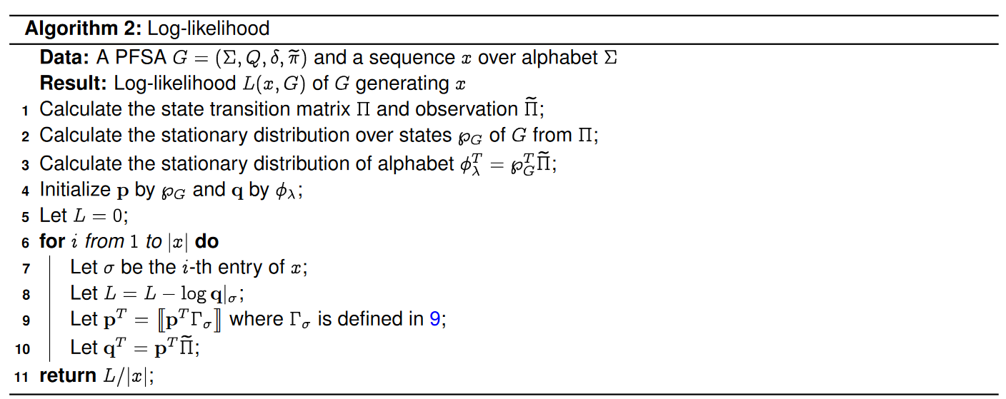

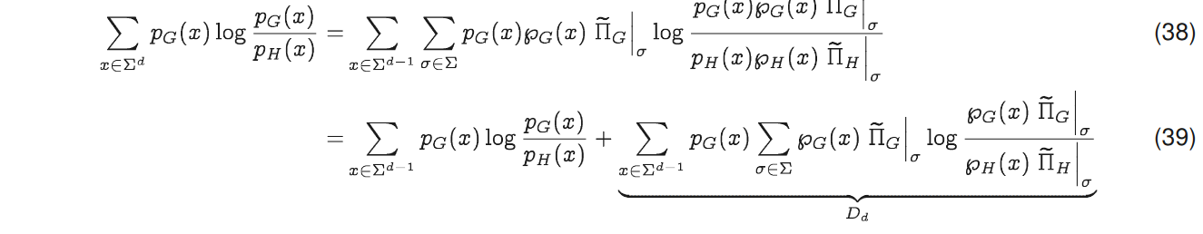Proof. We first notice that

By induction, we have , and hence by Cesàro summation theorem41, we have . Let be a sequence generated by . Let is the truncation of at the -th symbols, we have

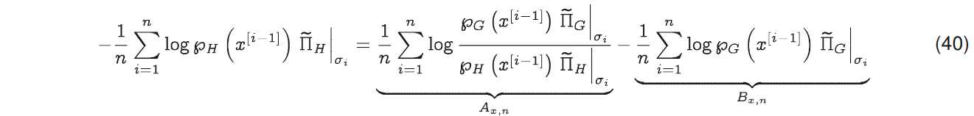Since the stochastic process generates is ergodic, we have

and .

## 12. Pipeline Optimization

### 12.1. *Input Data Format*

To encode the ICD-9 codes, 17 Disease Groups of codes are used to transform the raw health records into a format suitable for PFSA. As described in , for each patient, the list of ICD-9 codes is encoded into a weekly array of three-symbol alphabet digits with respect to selected disease group, for each week: ”0” - no disease ”1” - disease from the selected group, ”2” - other disease.

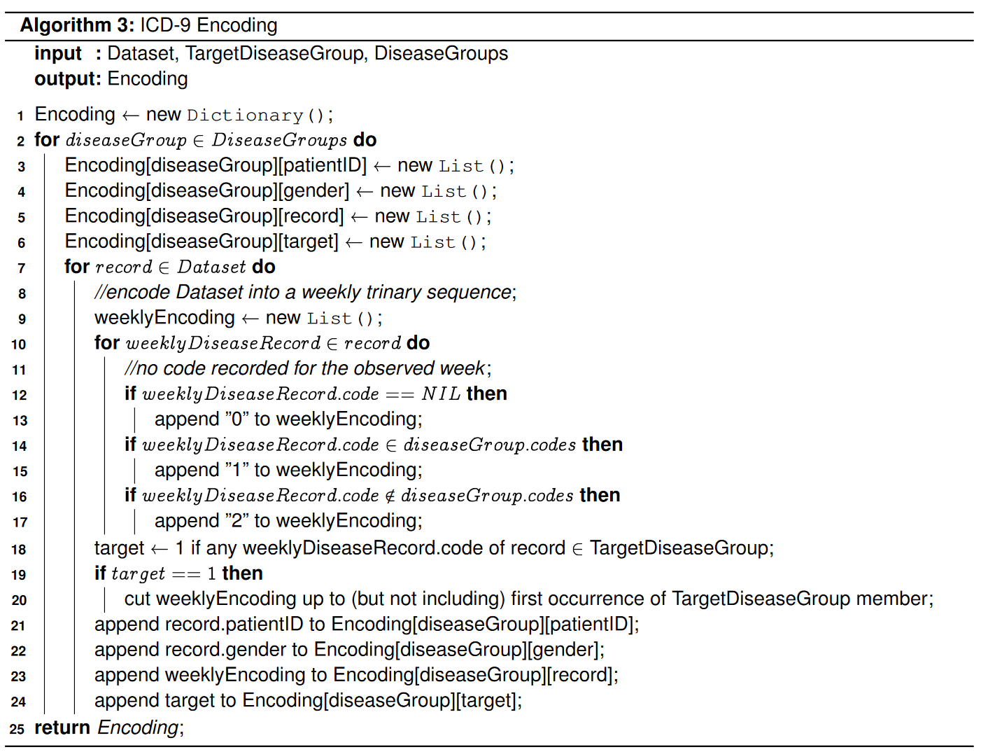

Once the trinary encodings are ready, the PFSA pairs are fit for each of the disease groups, on positive (treatment)and negative (control) sets using genESeSS algorithm3 (See Section 10), as described in . The PFSA pairs are then used to obtain the loglikelihood scores of belonging to a PFSA modeling the positive and the control cohorts accordingly for each of the encodings of a patient record. As a result, we yield the difference between positive and control loglikelihoods for each disease group of each patient. The positive value of difference means that with respect to a given disease group, a certain patient is more likely to be a positive one. Conversely, the negative value of difference signifies that a patient is more likely to be from the control group. These features, as well as their aggregations and the aggregations of the ternary encoding arrays, are used as the features for the final LightGBM gradient boosting classifier.



*12.2. Algorithms*

The key data processing approach is outlined in Algorithm 3. The remaining steps of the approach are sketched in Algorithm 4. Fig. 8 shows the overall schema, including the breakdown of a database into a test set, and two training sets: one for training the HMM models, and one for training the boosting classifier.

## 13. Example Run with Released Application

### 13.1. Prerequisites & Installation

The minimum prerequisites for running ehrzero are the following:

1. An x64 system running any flavor of Linux.
2. A working python 3.x installation
3. scikit-learn, version = 0.20.0

Installation:

pip3 install ehrzero –user

### 13.2. EHR data format

Diagnostic data stored in text file, one line per patient as follows: patient id, gender, and list of space-separated, comma-delineated diagnosis records, all separated by spaces. Each diagnosis record consists of the week since the start of the observation, followed by a comma, and the ICD-9 code of the diagnosis.

Example of a patient line:

Lorax,M 5,277.03 10,611.79 18,057.8 58,157.8 78,057.8 108,057.8 128,057.8 148,057.8

### 

### 13.3. Sample Python code risk estimation

Once the patient diagnostic data is in the required format, for function predict_with_confidence we specify the filepath of the data and the list of the cutoffs for the first weeks since the start of observations for the data we want to analyze. We also specify the separator and delimiter for the patients within file (space and comma are default values, but can be changed for user convenience).

The predict_with_confidence function returns the predicted risk of autism for every patient in the input file with all the specified numbers of first weeks to consider.

### 13.4. Sample Python script risk estimation

The script version is similar to the one mentioned before. Once ehrzero package is installed, locate its directory and go to ../ehrzero/example. Select one of the".dx" or ".dat" files in /ehrzero/example/tests as input and run the following command as an example:

python zero.py -data tests/ZEROexample.dat -outfile predictions.csv -nweeks 100 200 300 -Verbose 1

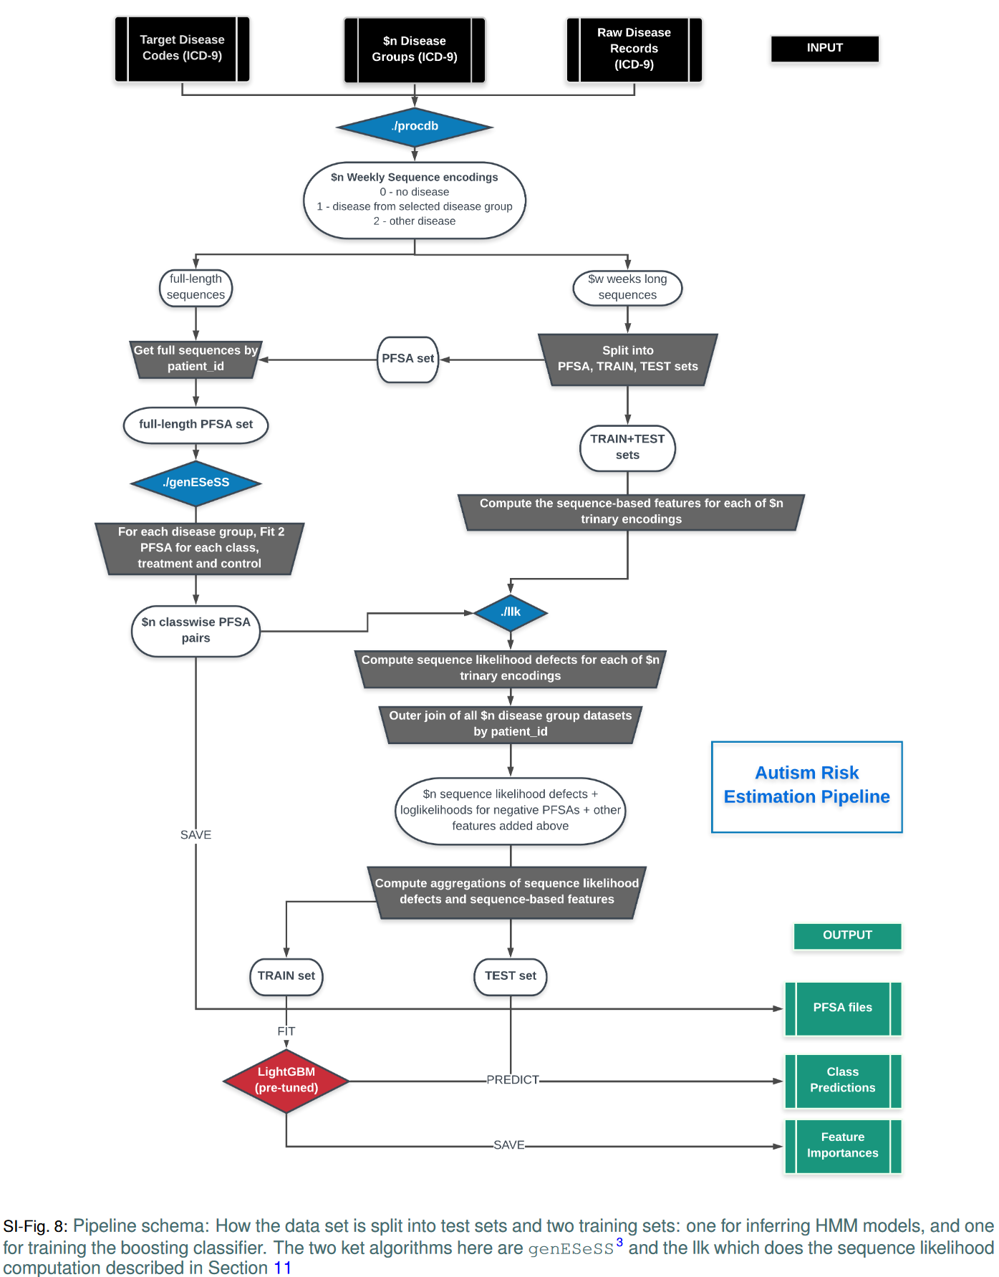

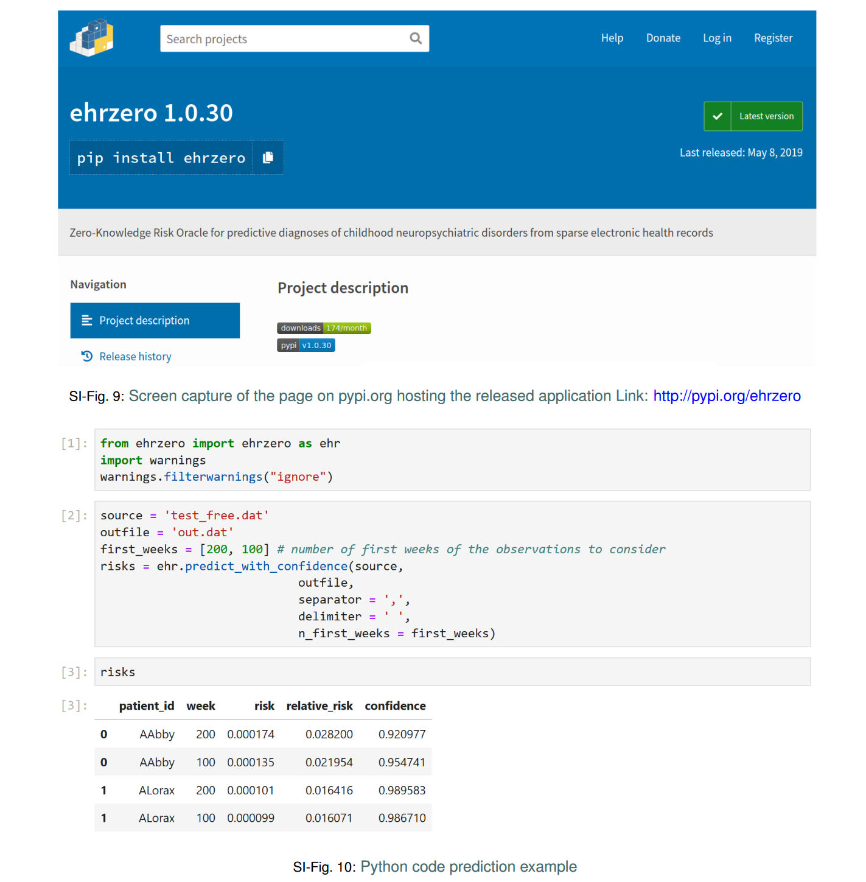

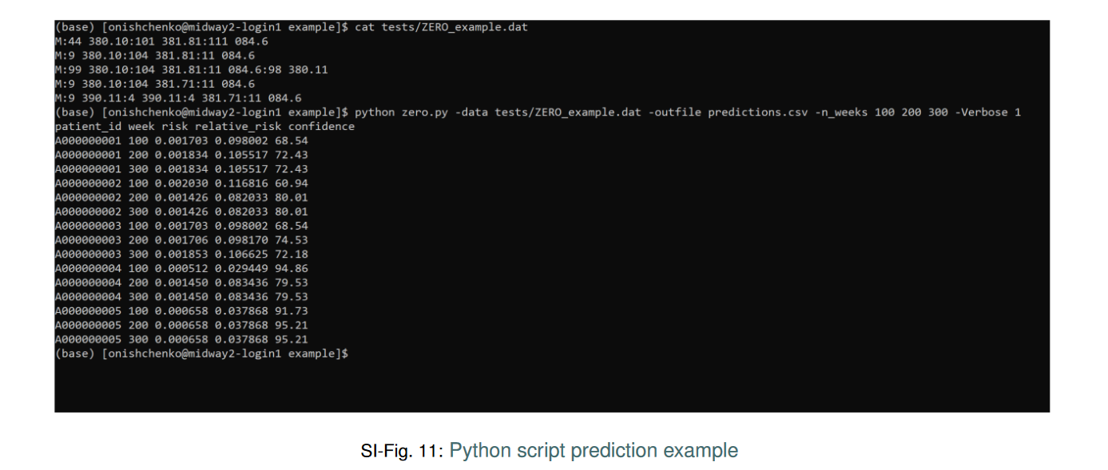

**References**

[1] Guthrie, W. *et al.* Accuracy of Autism Screening in a Large Pediatric Network. *Pediatrics* **144** (2019).

[2] Granger, C. W. J. & Joyeux, R. An introduction to long-memory time series models and fractional differencing. *Journal of Time Series Analysis* **1**, 15–29.

[3] Chattopadhyay, I. & Lipson, H. Abductive learning of quantized stochastic processes with probabilistic finite automata. *Philos Trans A* **371**, 20110543 (2013).

[4] General equivalence mappings. URL <https://www.cms.gov/Medicare/Coding/ICD10/downloads/ICD-10_GEM_fact_sheet.pdf>.

[5] Cover, T. M. & Thomas, J. A. *Elements of Information Theory (Wiley Series in Telecommunications and Signal Processing*) (Wiley-Interscience, New York, NY, USA, 2006).

[6] Kullback, S. & Leibler, R. A. On information and sufficiency. *Ann. Math. Statist.* **22**, 79–86 (1951). URL <https://doi.org/10.1214/aoms/1177729694>.

[7] Doob, J. *Stochastic Processes*. Wiley Publications in Statistics (John Wiley & Sons, 1953). URL <https://books.google.com/books?id=KvJQAAAAMAAJ>.

[8] Friedman, J. H. Stochastic gradient boosting. *Comput. Stat. Data Anal.* **38**, 367–378 (2002). URL <http://dx.doi.org/10.1016/S0167-9473(01)00065-2>.

[9] Breiman, L. Random forests. *Mach. Learn.* **45**, 5–32 (2001).

[10] Friedman, J. H. Stochastic gradient boosting. *Comput. Stat. Data Anal.* **38**, 367–378 (2002).

[11] Hochreiter, S. & Schmidhuber, J. Long short-term memory. *Neural Comput*. **9**, 1735–1780 (1997).

[12] Gordon-Lipkin, E., Foster, J. & Peacock, G. Whittling down the wait time: exploring models to minimize the delay from initial concern todiagnosis and treatment of autism spectrum disorder. *Pediatric Clinics* **63**, 851–859 (2016).

[13] Penner, M., Anagnostou, E. & Ungar, W. J. Practice patterns and determinants of wait time for autism spectrum disorder diagnosis incanada. *Molecular autism* **9**, 16 (2018).

[14] Hyman, S. L., Levy, S. E., Myers, S. M. et al. Identification, evaluation, and management of children with autism spectrum disorder. *Pediatrics* **145** (2020).

[15] Johnson, C. P., Myers, S. M. et al. Identification and evaluation of children with autism spectrum disorders. *Pediatrics* **120**, 1183–1215 (2007).

[16] Zwaigenbaum, L.et al.Early intervention for children with autism spectrum disorder under 3 years of age: recommendations for practice and research. *Pediatrics* **136**, S60–S81 (2015).

[17] Robins, D. L.et al. Validation of the modified checklist for autism in toddlers, revised with follow-up (m-chat-r/f). *Pediatrics* **133**, 37–45(2014).

[18] Esler, A. N.et al. The autism diagnostic observation schedule, toddler module: standardized severity scores. *Journal of Autism and Developmental Disorders* **45**, 2704–2720 (2015).

[19] Chlebowski, C., Green, J. A., Barton, M. L. & Fein, D. Using the childhood autism rating scale to diagnose autism spectrum disorders. *Journal of autism and developmental disorders* **40**, 787–799 (2010).

[20] Falkmer, T., Anderson, K., Falkmer, M. & Horlin, C. Diagnostic procedures in autism spectrum disorders: a systematic literature review. *European child & adolescent psychiatry* *22*, 329–340 (2013).

[21] Lord, C. et al. Autism from 2 to 9 years of age. *Archives of general psychiatry* **63**, 694–701 (2006).

[22] Kleinman, J. M. et al. Diagnostic stability in very young children with autism spectrum disorders.*Journal of autism and developmental disorders* **38**, 606–615 (2008).

[23] Bolton, P. F., Golding, J., Emond, A. & Steer, C. D. Autism spectrum disorder and autistic traits in the avon longitudinal study of parents and children: precursors and early signs. *Journal of the American Academy of Child & Adolescent Psychiatry* **51**, 249–260 (2012).

[24] Kozlowski, A. M., Matson, J. L., Horovitz, M., Worley, J. A. & Neal, D. Parents’ first concerns of their child’s development in toddlers withautism spectrum disorders. *Developmental neurorehabilitation* **14**, 72–78 (2011)

.[25] Baio, J. Prevalence of autism spectrum disorder among children aged 8 years-autism and developmental disabilities monitoring network, 11 sites, united states, 2010 (2014).

[26] Kalb, L. G.et al.Determinants of appointment absenteeism at an outpatient pediatric autism clinic. *Journal of Developmental & Behavioral Pediatrics* **33**, 685–697 (2012).

[27] Bisgaier, J., Levinson, D., Cutts, D. B. & Rhodes, K. V. Access to autism evaluation appointments with developmental-behavioral and neurodevelopmental subspecialists. *Archives of pediatrics & adolescent medicine* **165**, 673–674 (2011).

[28] Fenikilé, T. S., Ellerbeck, K., Filippi, M. K. & Daley, C. M. Barriers to autism screening in family medicine practice: a qualitative study. *Primary health care research & development* **16**, 356–366 (2015).

[29] Althouse, L. A. & Stockman, J. A. Pediatric workforce: A look at pediatric nephrology data from the american board of pediatrics. *The Journal of pediatrics* **148**, 575–576 (2006).

[30] Hopcroft, J. E. Introduction to automata theory, languages, and computation (Pearson Education India, 2008).

[31] Klenke, A.Probability theory: a comprehensive course (Springer Science & Business Media, 2013).

[32] Doob, J. Stochastic processes. Wiley publications in statistics (Wiley, 1990). URL <https://books.google.com/books?id=7Bu8jgEACAAJ>.

[33] Chattopadhyay, I. & Ray, A. Structural transformations of probabilistic finite state machines. *International Journal of Control* **81**, 820–835(2008).

[34] Chattopadhyay, I. & Lipson, H. Data smashing: uncovering lurking order in data. *Journal of The Royal Society Interface* **11**, 20140826(2014).

[35] Bondy, J. & Murty, U. Graph theory (2008). *Grad. Texts in Math* (2008).

[36] Vidyasagar, M. *Hidden markov processes: Theory and applications to biology*, vol. 44 (Princeton University Press, 2014).

[37] Kai, L. C. *Markov Chains: With Stationary Transition Probabilities* (Springer-Verlag, 1967).

[38] Trahtman, A. N. The road coloring and ̆Cern ́y conjecture. InProc. of Prague stringology conference, vol. 1, 12 (Citeseer, 2008).

[39] Cover, T. M. & Thomas, J. A. *Elements of information theory* (John Wiley & Sons, 2012).

[40] Matthews, A. G. d. G., Hensman, J., Turner, R. & Ghahramani, Z. On sparse variational methods and the kullback-leibler divergence between stochastic processes. *Journal of Machine Learning Research* **51**, 231–239 (2016).

[41] Hardy, G. Divergent series, with a preface by je littlewood and a note by ls bosanquet, reprint of the revised (1963) edition. Éditions Jacques Gabay, Sceaux(1992).

1. To whom correspondence should be addressed: e-mail: ishanu@uchicago.edu.